Project Title

Proposal

Focus Area
Select the CHAIRE focus area(s) for your proposal
Conservation | Companionship | Welfare & Behavior | Zooeyia

Must be typed in 11-point Arial or Calibri font, single-line spacing, and 1-inch page margins

Authors
This document was prepared by:
<Insert contact information for each author as indicated. Highlight CHAIRE member(s)>
Author, PI
Office Phone:
email

Table of Contents
1. PROJECT ABSTRACT (250 WORD LIMIT) 3

2. PROJECT SUMMARY/SPECIFIC OBJECTIVES (1 PAGE)______________________3
3. PROJECT STRATEGY (6 PAGES) 3
3.1 BACKGROUND AND SIGNIFICANCE 3
3.2 PRELIMINARY STUDIES OR DATA (IF AVAILABLE) 4
3.3 APPROACH 4
3.4 DELIVERABLES 4
3.5 LITERATURE CITED 4

4. TEAM AND PARTNERS 4
5. COSTS / BUDGET 5
5.1 BUDGET AND INCOME TABLE 5
5.2 BUDGET NARRATIVE 5
5.3 METRICS 5
6. DOCUMENTATION SUPPORT 6

Project Abstract
<250 word limit>

Project Summary/Specific Objectives
<1 page limit>
<Include brief summary of proposal, Goal or Hypothesis (if appropriate), prior experience of team to address proposed challenge, Specific Objectives that will be accomplished and proposed time frame to complete the Specific Objectives. Objectives clarify what your team expects to accomplish in the specific project funded by CHAIRE. Specific Objectives are concise statements of intended achievements by the project team and support the overarching goal outlined above. Objectives should be viewed as criteria the project needs to meet in order to be considered a success. Objectives should be SMART (Specific, Measurable, Attainable, Realistic and Time-bound). Include community and scholarship impacts the project must have to be considered successful and how those impacts will be measured. It does not need to be stated but it is inherent in the objectives to complete the project within the time, cost, and scope constraints defined by this document.>

Project Strategy
<6 page limit>
<Must be typed in 11-point Arial or Calibri font, single-line spacing, and 1-inch page margins>

Background
<This section describes: 1) the challenge/opportunity to be addressed, 2) nature, scope and significance of the challenge or opportunity, including supporting references , and 3) provides the background and support for why the proposed program is needed, including how it is new/different and better than other options.>

[It is advised that you use this section to support the specific rationale or need for your proposal and how it adds value to existing programs or research evidence in the area of interest.]

Preliminary Studies or Data (if available)
<This section is your opportunity to provide early evidence from your team that you have already established some data or progress toward meeting your Specific Objectives in the proposal.>
[This section may be entirely narrative or may represent data figures, tables, or photographs that reflect preliminary information about your project that provide support for the feasibility of your team to accomplish your Specific Objectives.]

Approach
<This section lays out the proposed project: 1) The overarching goal of the specific project 2) the specific plan how you will accomplish the stated Objectives of the proposal the specific plan a project including any standard or innovative methodologies to be used and relevant details of the methodologies; 4) target audience (who will be served), 5) why the audience is ready for or interested in the program; 6) why the timing is right for the proposal; and 7) how the program will benefit and have an impact on your target audience.>

3.4 Deliverables
<A deliverable is any measurable, tangible, verifiable outcome, result, or item that is required to complete the program/project funded by the grant (e.g., report, prototype, publication, app). Develop a list of deliverables and where, when, and to whom the deliverables are to be provided.>

3.5 Literature Cited
[References should be included to support your proposed approach or methodologies and is also an opportunity for you to reference your own work from the applicant team, if available, to further support why your team is capable of completing the proposed project.]
<And as a reminder, section 3.1-3.5 must not exceed 6 pages>

Team and Partners
< 3 page limit>
<Document the team’s capacity to execute the proposed initiative. Identify members of the core team and existing or desired OSU and community partners, if any. Briefly discuss each team member’s role, capabilities and qualifications.>

[A brief bio of team members may be included indicating expertise. You may wish to indicate references or awards, if appropriate, to illustrate expertise. ]

Costs / Budget

Budget and Income Table
<The budget and income table provides a summary of expenses and income/support by personnel and milestone. The following is an example that can be customized to fit your project.>
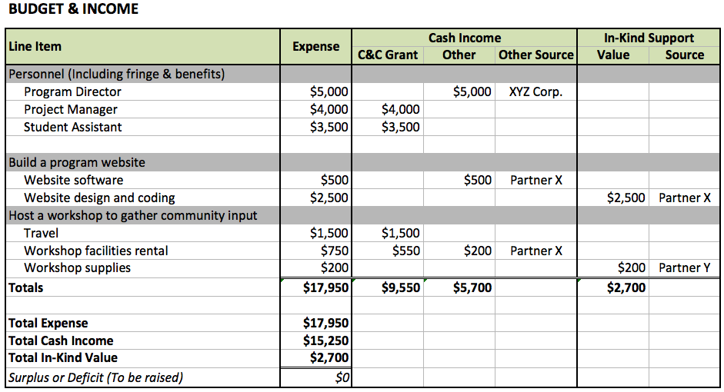

Budget Narrative
<State any additional information that you think may be helpful in explaining how funding will be applied to achieve proposed program/project outcomes. Include cost share and additional sources of funding. Also identify any expected budgetary overlap of existing or pending funding with your request for CHAIRE funding.>

Metrics
<As a measure of impact, CHAIRE collects data on anticipated partners and cost share of awarded projects. Please provide this data by completing the section below. You should be able to extract this information from the budget summary. Please use full names instead of acronyms.>
- Team Lead(s) and their college/regional campus/unit.
- The college/unit of OSU partners.
- The names of non-OSU partners.

DOCUMENTATION SUPPORT
<Attach letters of support and commitment.>

